EXP: 2
Date : 10-07-2026
DDL Commands with Constraints – PRIMARY, FOREIGN KEY, UNIQUE, CHECK
AIM: To add the constraints like primary key, foreign key, unique key and check using DDL commands.
Description:
PROCEDURE:
Step 1: Create the Patients table with the required attributes.
Step 2: Add PRIMARY KEY constraint on the P_id column.
Step 3: Add a UNIQUE constraint on the Insurance column.
Step 4: Verify the table structure and insert patient records.
Step 5: Attempt to update the Insurance value of patient P_id = 204 to Star Health.
Step 6: Observe that MySQL displays a duplicate entry error because the UNIQUE constraint prevents duplicate values.
Step 7: Drop the UNIQUE index created on the Insurance column.
Step 8: Modify the Insurance column to ensure it remains NOT NULL.
Step 9: Update the Insurance value of P_id = 204 to Star Health again.
Step 10: Display all records to verify that duplicate Insurance values are now allowed after removing the UNIQUE constraint.
Query 1:
ALTER TABLE patients ADD PRIMARY KEY (P_id);
OUTPUT 1 :
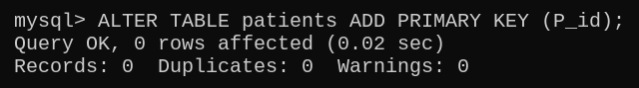
Query 2 :
ALTER TABLE patients MODIFY Insurance VARCHAR(15) NOT NULL;
Output 2 :
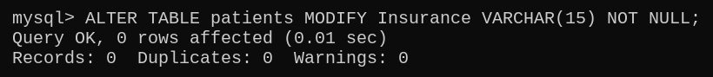
Query 3 :
ALTER TABLE patients ADD UNIQUE (Insurance);
Output 3 :
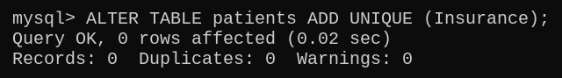
Query 4 :
ALTER TABLE patients ADD CONSTRAINT chk_pid CHECK (P_id >= 2);
Output 4 :
